[StoryWeb] Site Plan

[Claire Elder]

WDD 130

Overview

Purpose
This website’s purpose is to help users create their own choose-your-own adventure

Audience
The audience is meant for any creative writers, looking to expand their stories in a neat and organized way

Branding

Website Logo
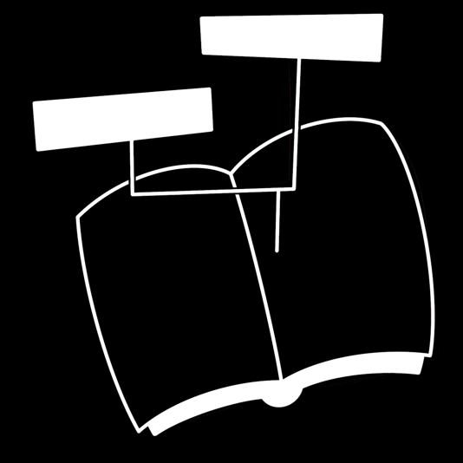

Style Guide

Color Palette
Primary | Secondary | Accent 1 | Accent 2
#607196 | #BABFD1 | #FF7B9C | #FFC759

Typography

Heading Font: Arial Rounded MT Bold

Paragraph Font: Avenir (light)

Navigation
Home Page2 Page3

Content

[put all content for the pages here, including written text and images]

Wireframes

Home
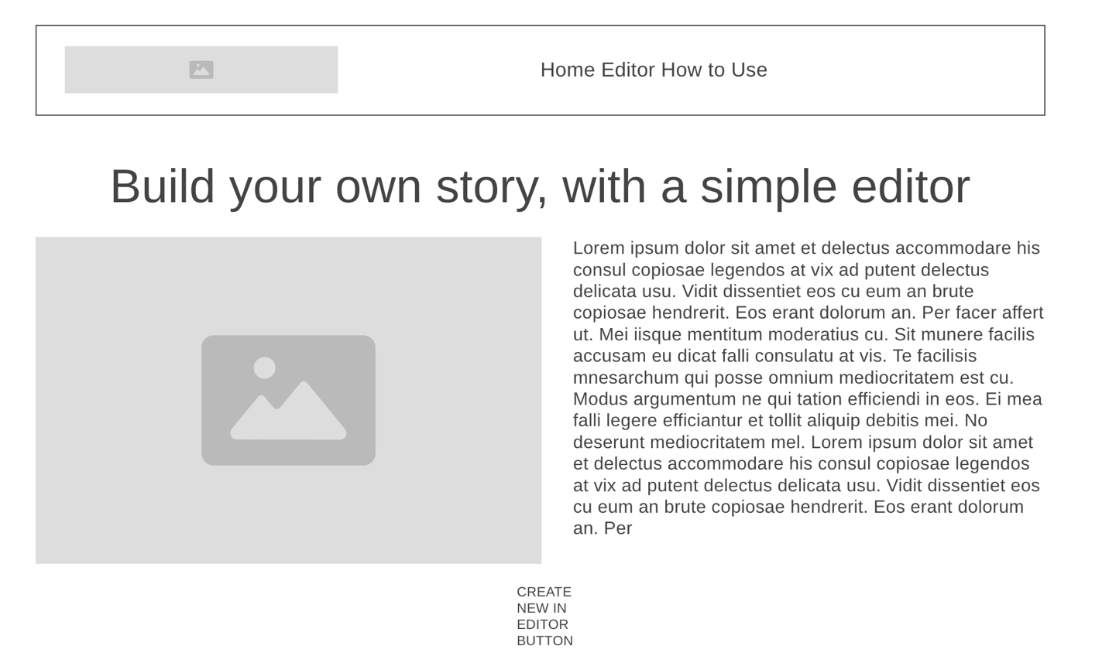

Editor
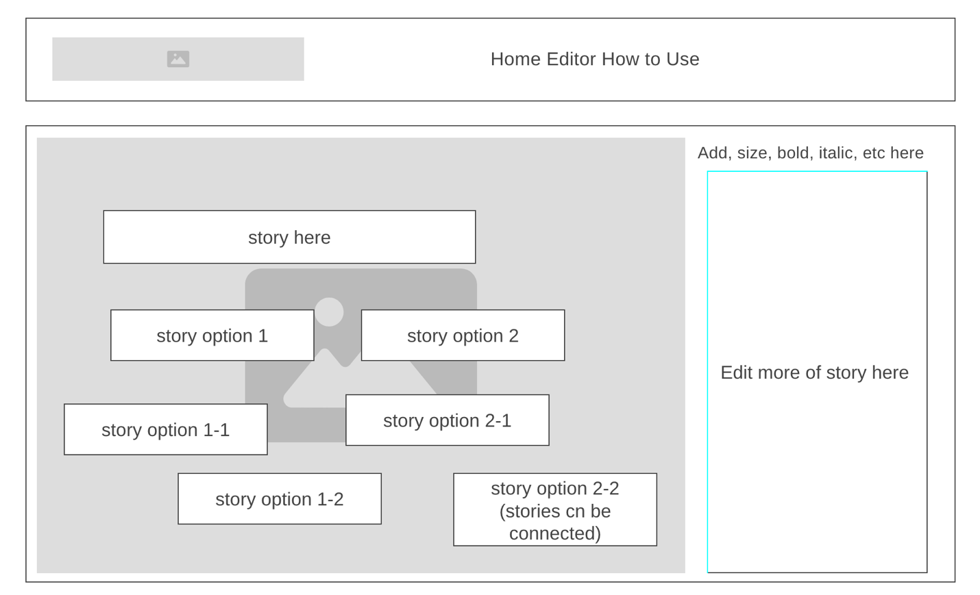

How to use
